**User Manual**

Dear User,

Thank you for playing our game! The following is a brief background of our project, and instructions for playing the game.

Our program is a Texas Hold’em Poker game with a visually stunning GUI and some very clever AI’s. Users without any computer science background should be able to launch and enjoy the game easily. The details of the Graphic User Interface (animations and high resolution pictures) provide a vivid and enjoyable gaming experience. Users play against three artificially intelligence opponents. May you be warned, AI opponents will not be easily defeated! They are clever enough to make the game fairly challenging.

**Background & Motivation**

This game is motivated by four enthusiastic poker playing computer scientists. We have spent years enjoying many different kinds of board games including poker, monopoly and Magic the Gathering, as well as computerized versions. There exist very nicely built computer programs for many of these other games. However, we can only find some crude flash Texas Hold’em games online. Therefore, from our love of Texas Hold’em we decided to build a nicely designed version of the game to play from one’s very own personal computer.

Our Texas Hold’em game has three AIs and one human player. The player can call, raise, fold, or go all-in, just as players do in the traditional Texas Hold’em Poker game. This is accomplished using the buttons at the bottom of the game screen, as shown below.

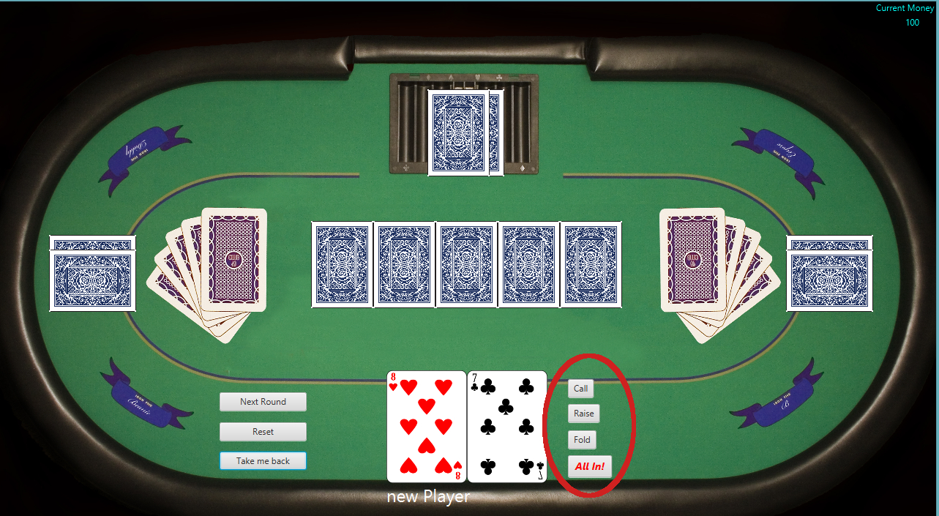

The biggest difference between our game and traditional Texas poker game is that 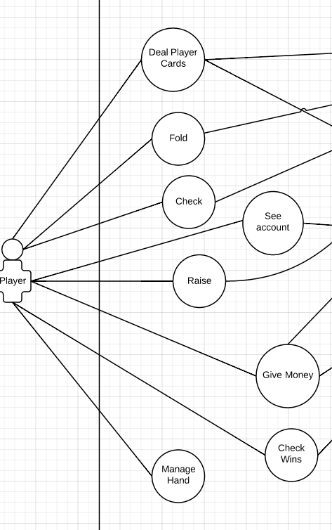players will have a more casino-like experience. Players won’t need to control the game flow (shuffle cards or neaten table) at all. Everything will be handled by an automated dealer. The player can continue to rake in virtual money, round after round, as the AI’s will continue to be initialized. This is why we say that it’s more of a casino-like experience. After each round, the human player can see their best five-card hand. If the player has won, this will be the winning hand that is displayed. The following are the user stories, or general goals, that we finished to implement our poker game:

|  |
| --- |
| As a player, I want to play TEXAS HOlD ‘EM |
| As a player, I want to be dealt a set of cards so that I can decide on my moves (randomly from deck of 52) |
| As a player, I want to have options to bet, fold, call and raise. |
| As a player, I want to have a visually stunning GUI. I can enjoy my game |
| As a player, I want to be able to drag and drop card in GUI. So that I can rearrange the card. |
| As a player, I want a range of difficulty options. |
| As a player, I want the game can let me play turn by turn. |

**Prerequisite for the program**

As of the current version, it is essential for you, the user, to have a java version of *8 update 40* or higher, and has a screen with resolution of *1280 *720* or higher.

**Game Instructions**

1: Launch game by running the “Main” executable file within the top-level directory of the game (default package)

2: A start menu will pop up. Users may select to play the game, read rules or exit in this menu.

3: If the user clicked to start the game, the GUI will show the main game user interface.

4: Now, the user has begun the main gameplay. The user is able to choose to call, raise, fold or all-in like any Texas Poker game. Two user cards and several pool cards will be set automatically.

5: When there is only one player left and other players fold, the winner of the round will be presented. If all players keep betting till the final bet, the winner will be presented with the best hand after the system automatically compares everyone’s hand.

6: After the winner is presented, users can choose to go to the next round or reset the game. Go to next round means that the game will continue with the same AIs and current money status. Reset game will result in a new game with default settings.

7: At any phase of the game, users will be able to go back to the start menu and choose to read the rules or exit the whole program.